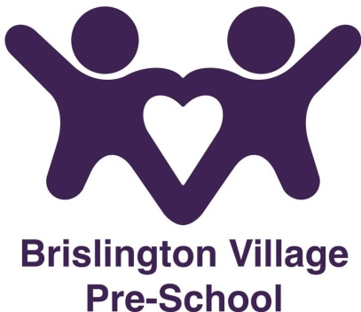

**Oral Hygiene Policy**

Reviewed November 2024

**Statement of Intent**

Our setting actively promotes good oral hygiene. This is important as good oral health keeps children free from toothache, infection and swollen gums.

**Aims**

Our setting will:

* provide information for parents on good oral hygiene practice
* Make sure that food and drink provided by Brislington Village Pre-school do not contain free sugars (e.g. sugar that has been added by a manufacturer)
* Have activities for the children to engage with them in good oral hygiene and why it is important

**Methods**

There are 3 main areas for good dental health

* Keep sugary and acidic foods to mealtimes
* Brush teeth at least twice a day with a fluoride toothpaste
* Visit a dentist regularly

The amount of toothpaste on your child’s toothbrush should be pea-sized for children aged 3+ years who can spit out and grain of rice size for those who are not able to yet.

Below are listed videos that can be shared with the children either at home or at the setting with top tips about tooth brushing.

Hey Dugee

<https://www.youtube.com/watch?v=oStaJTHgHMU>

Finny the Shark

<https://www.youtube.com/watch?v=3X4Udn7lbuY>

The Tooth brushing song

<https://www.youtube.com/watch?v=O4wDITXrvrc>

This policy was adopted at a meeting on 7th May 2024

Reviewed November 2024

This policy should be read in conjunction with our:-

Health and safety policy

Although under constant review, an overall review date has been set for **September 2025**